Preparing apps for the store

BUNDLE GUIDELINES
- Ribbon buttons
  - Need to have Ribbon Button (not under external tolos)
  - Add-ins tab (by default)
  - Custom tabs (optional)
  - Autodesk icon Guidelines.pdf under Revit SDK
  - Autodesk WikiHelp > Revit > developers > Appendices > API user Interface Guidelines > Ribbon Guidelines
http://wikihelp.autodek.com/Revit/enu/2014/Help/3665-Developers/0170-Appendic170/0206-API_User206/0215-Ribbon_G215
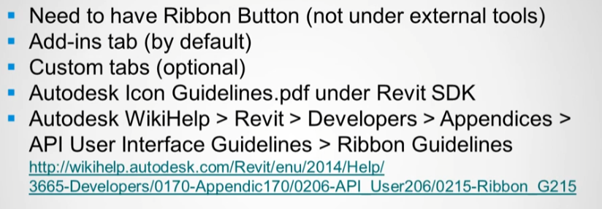
- Revit: Custom ribbon panels and controls (such as push buttons, split buttons, and radio groups) are primarily managed through the Revit API for add-ins. The API allows developers to create custom tabs, add controls, and associate contextual help links.

- Contextual (F1) help
  - RibbonItem.SetContextualHelp()
  - Link to :
    - External URL
    - Local help file
    - Autodesk help file
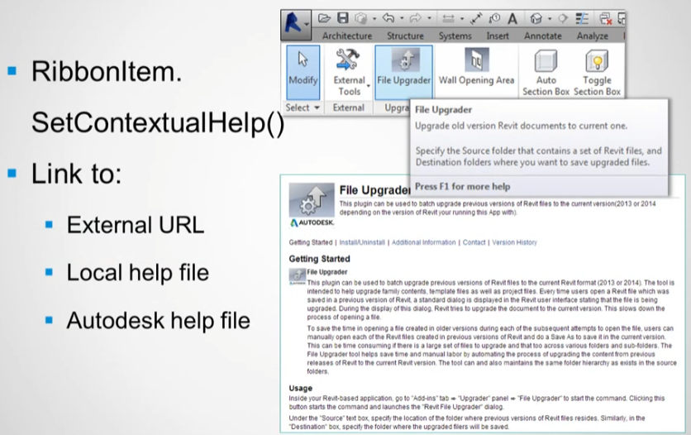
- Install locations
  - All users (default)
%ProgramData%\Autodesk\ApplicationPlugins\<myApp>.bundle

  - Per User
%AppData%\Autodesk\ApplicationPlugins\<myApp>.bundle

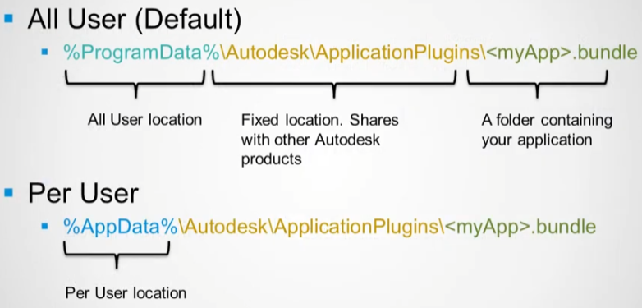

- “Bundle” structure.
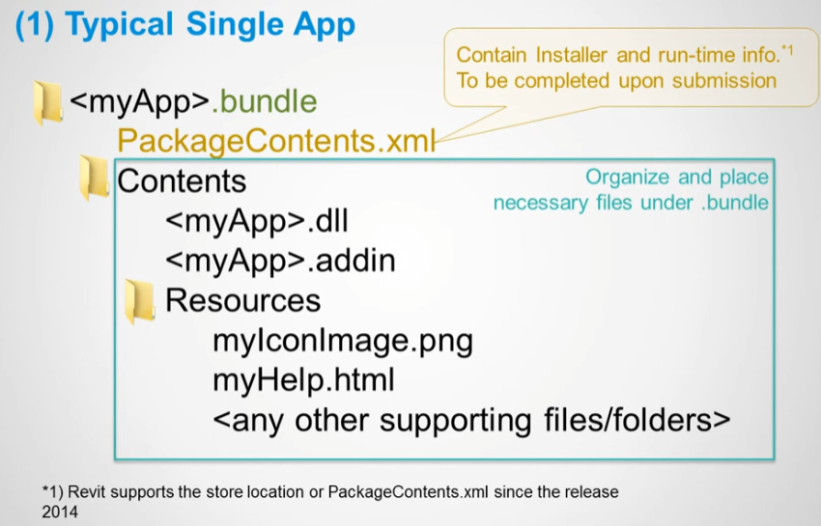
PackageContent is created by autodesk in the initial submission process of the App.
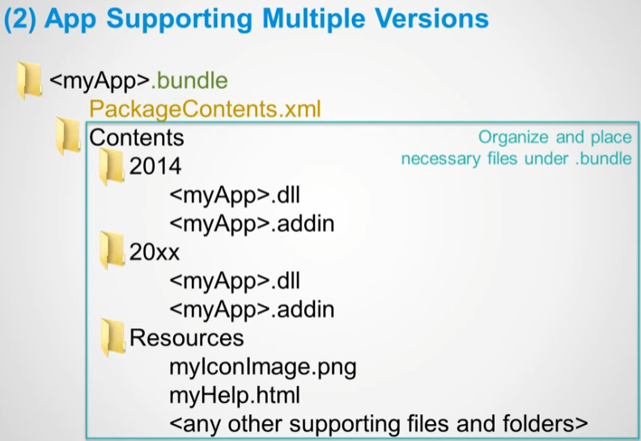
PackageContents.xml
- Generated by Autodesk installer tool after the initial submission o fan App (populated from submission information. No need for Publisher to provide as such)
- Contains installer information
- Revit 2014 (and above) Will read this file and pick up the location of .addin manifest
- Important: keep it in your bundle once it is generated after the initial submission
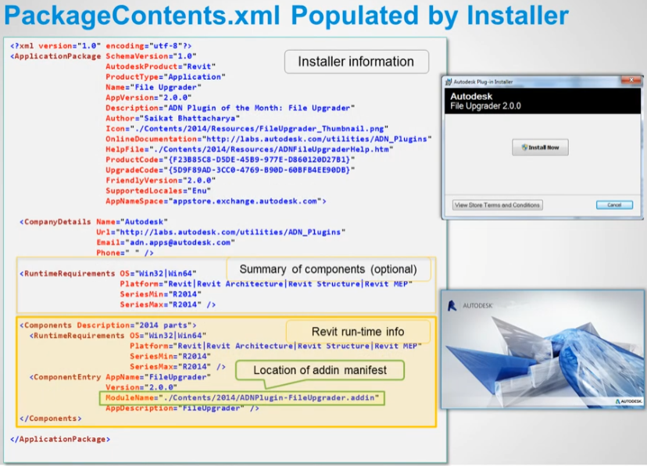
REVIT APP AUTO LOAD FLOW
  - Revit goes through the common install folder and parse for Revit apps for the appropiate environments (RuntimeRequirements).
  - Revit picks up the location od addin manifest (ModuleName).
  - Read .addin manifest and load the app.
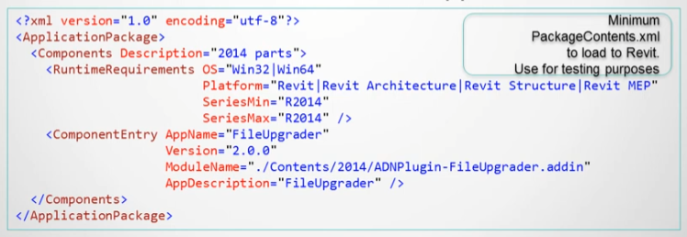
ADDIN MANIFEST
- Use the relative path to your dll.
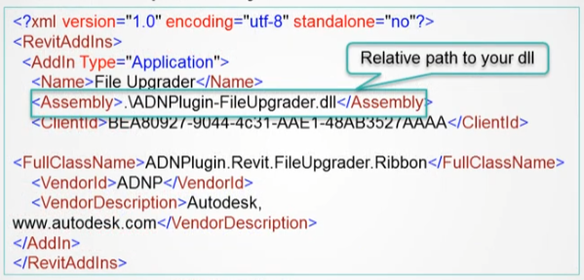
-By default, Revit Will load addins without restarting Revit
If you want tochange this behaviour, add the flag (Revit support in-session loading since the reléase 2014. Earlier releases require restarting Revit):
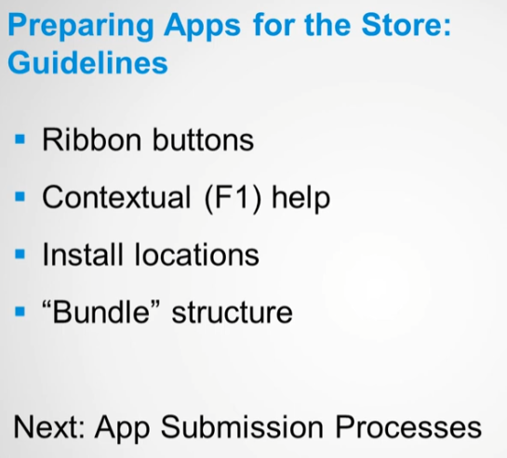

PUBLISHING INFO
